**1.Create a directory’project_dir’&cd to ‘project_dir’.**

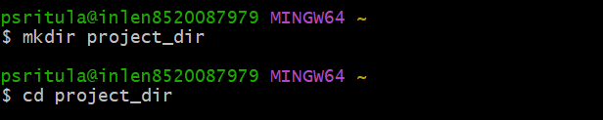

**2.Intialize git version database.(git init)**



**3.Create a new file index.html.**



**4.Check the git status. You should find index.html as untracked file.**

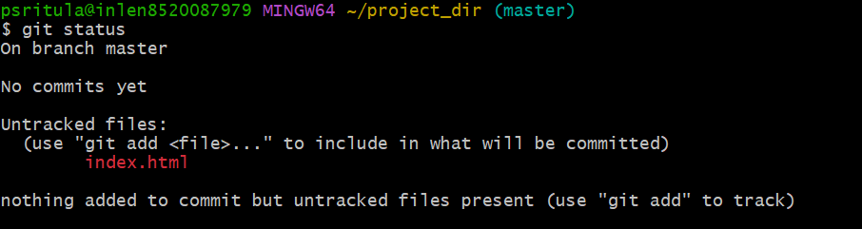

**5.Stage the index.html file.**



**6.Commit index.html**

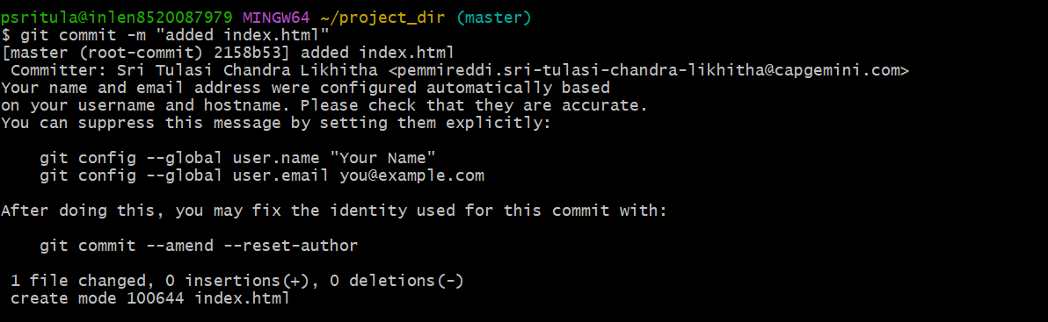

**7.Make few changes in index.html & create a new file info.txt file.**

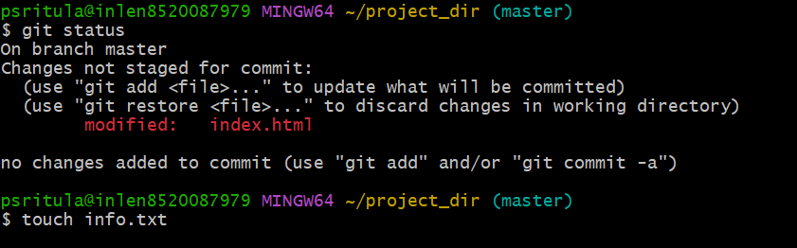

**8.check git status.You should find index.html & info.txt as untracked files.**

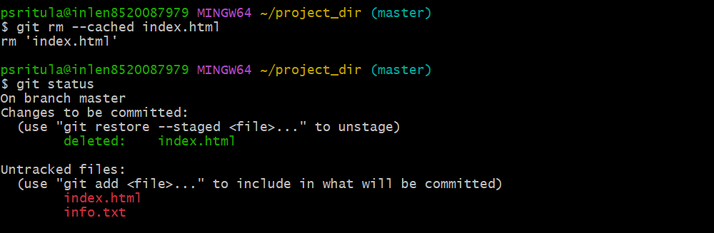

**9.Configure GIT to ignore all txt files.**



**10.Again check the git status.you should find only index.html as untracked file.**

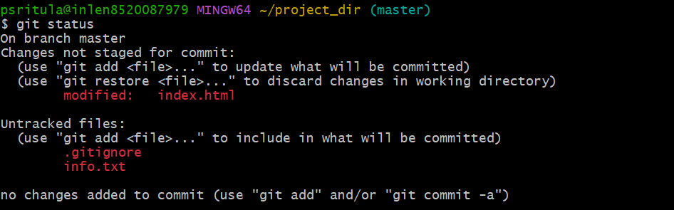

**11.state & commit index.html**

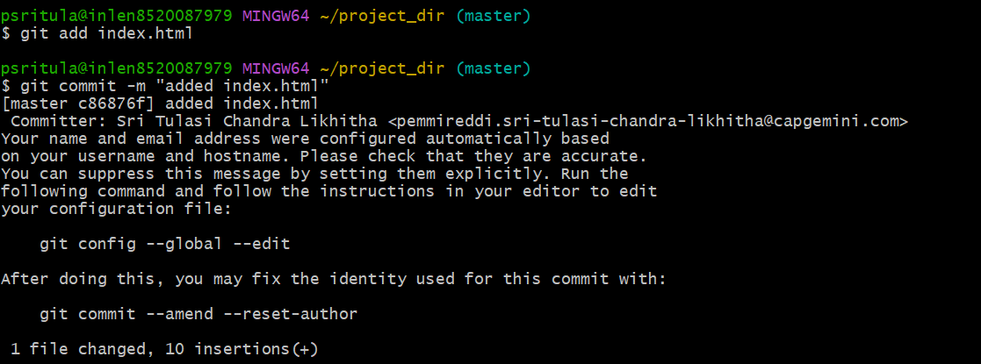

**12.Log all your comments so far.**

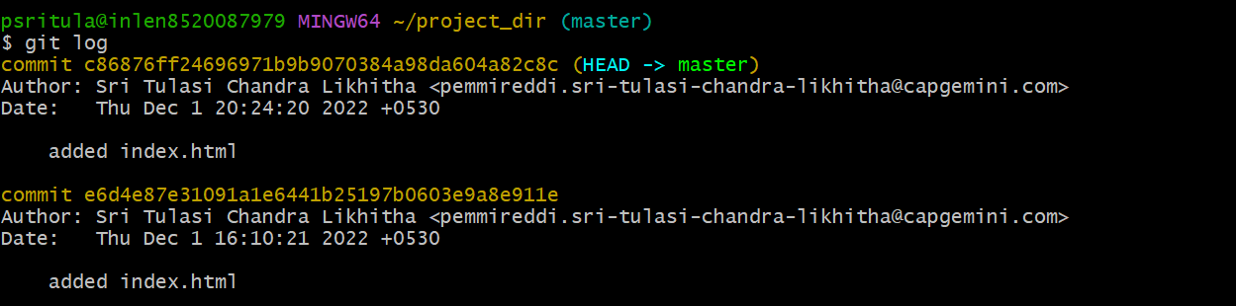

**13.Make some changes in index.html.**

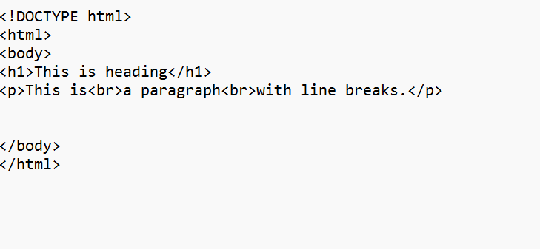

**14.Revert the change made in the previous step using git command.**



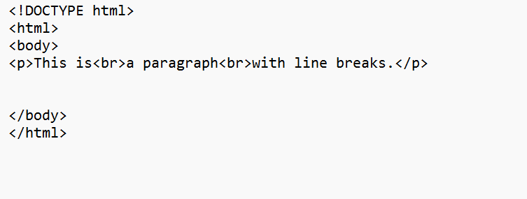

**15.Again change index.html.**

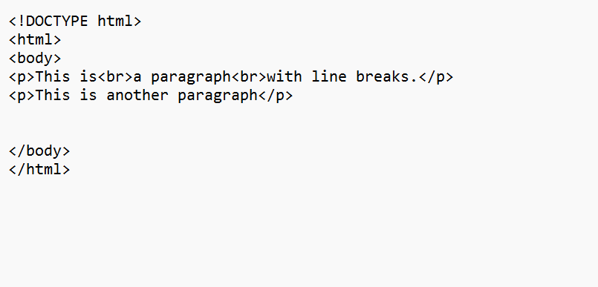

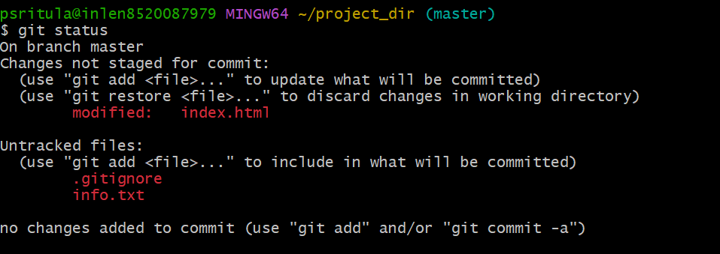

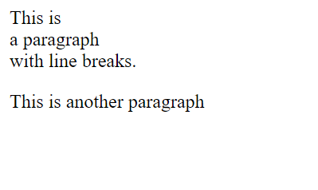

**16.Stage index.html**



**17.Revert back the last stage.**

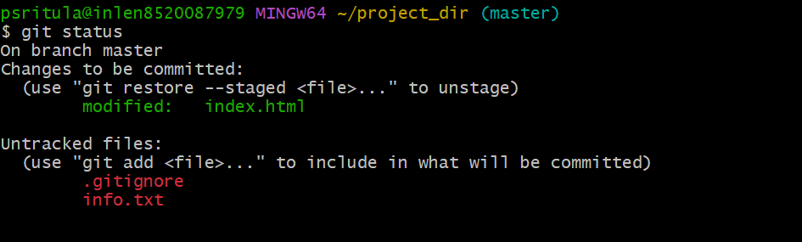

**18.Rename ‘add’command to ‘my-add’**



**19.Using my_add command stage index.html again & commit the changes.**

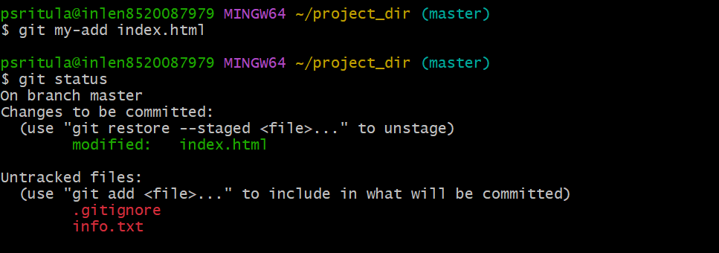

**20.Revert the last commit.**

